EXP:4 CREATE A WEB PAGE TO ACCEPT USERNAME AND AGE AND
DISPLAY IT ON BROWSER

AIM:
Create a web form that accepts a user's name and age. Write a Servlet to process the form data and display it back on the browser.

CODE:
INDEX.HTML
<!DOCTYPE html>
<html>
<head>
<meta charset="ISO-8859-1">
<title>Web-Page</title>
</head>
<body>
<form action="/janani/DisplayUser">
<p>
<label for="username">Username:</label>
<input type="text" class="username" name="username" placeholder="Enter your name" required/><br><br>
</p>
<p>
<label for="age">Age:</label>
<input type="number" class="age" name="age" placeholder=" Enter Age">
</p>
<input type="submit" value="Accept">
</form>
</body>
</html>

DISPLAYUSER.JAVA

package com.janani.servlet;

import java.io.IOException;
import java.io.PrintWriter;

import javax.servlet.ServletException;
import javax.servlet.annotation.WebServlet;
import javax.servlet.http.HttpServlet;
import javax.servlet.http.HttpServletRequest;
import javax.servlet.http.HttpServletResponse;

/**
* Servlet implementation class DisplayUser
*/
@WebServlet("/DisplayUser")
public class DisplayUser extends HttpServlet {
private static final long serialVersionUID = 1L;

/**
* @see HttpServlet#HttpServlet()
*/
public DisplayUser() {
super();
// TODO Auto-generated constructor stub
}

/**
* @see HttpServlet#doGet(HttpServletRequest request, HttpServletResponse response)
*/
protected void doGet(HttpServletRequest request, HttpServletResponse response) throws ServletException, IOException {
String a = request.getParameter("username");
int b = Integer.parseInt(request.getParameter("age"));
PrintWriter p=response.getWriter();
if(b<=0){
p.println("Login Failed");
}
else {
p.println(a);
p.println(b);
}
}

/**
* @see HttpServlet#doPost(HttpServletRequest request, HttpServletResponse response)
*/
protected void doPost(HttpServletRequest request, HttpServletResponse response) throws ServletException, IOException {
// TODO Auto-generated method stub
doGet(request, response);
}

}

OUTPUT:

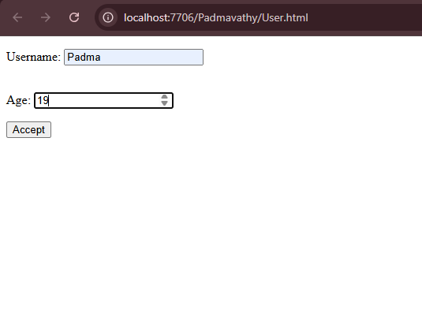

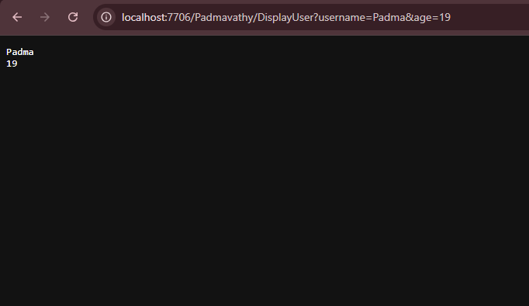

RESULT:
Validating the username and age is is done successfully and displayed in the browser.

